Project Title: [World Gym]

# Business Requirement Document

|  |  |
| --- | --- |
| **Author Name:** | SELVASEKAR M |
| **Date:** | 16-JULY-2024 |
| **Version:** | 1.1.4 |
| **Status:** | In progress |

# Table of Contents

1. Introduction ……………………………………………………………………………………………………………*03*

1.1 Project Overview …………………………………………………………………………………………………...*03*

1.2 Purpose …………………………………………………………………………………………………………………*03*

1.3 Scope …………………………………………………………………………………………………………………*03-04*

1.4 Definitions, Acronyms, and Abbreviations ……………………………………………………………....*04*

1.5 References …………………………………………………………………………………………………………….*04*

2. Business Objectives ………………………………………………………………………………………………*04-05*

3. Stakeholders ………………………………………………………………………………………………………...*05-07*

3.1 Stakeholder Identification ………………………………………………………………………………….*05-06*

3.2 Stakeholder Roles and Responsibilities ……………………………………………………………….*06-07*

4. Requirements ………………………………………………………………………………………………………*07-16*

4.1 Functional Requirements ……………………………………………………………………………………*07-15*

4.2 Non-Functional Requirements …………………………………………………………………………….*15-16*

5. Assumptions and Constraints ……………………………………………………………………………….*16-17*

6. Glossary ……………………………………………………………………………………………………………………*17*

7. Approval …………………………………………………………………………………………………………………...*18*

7.1 Sign-Off …………………………………………………………………………………………………………………...*18*

# 1. Introduction

## 1.1 Project Overview

## By completing this project, end users will be able to search for gyms nearby by entering their current zip code. This website will enable users to find yoga, cycling, and strength classes just by providing their current zip code. This project aims to help a significant number of people discover top-rated gyms in their vicinity with ease.

## 1.2 Purpose

The purpose of this project is to deliver a valuable and user-friendly website that will significantly benefit end users. Additionally, this project aims to establish a profitable venture by leveraging the website's capabilities to attract and retain customers.

## 1.3 Scope

**In Scope:**

* **Designing and user interface:** Designing a website and creating an user friendly interface.
* **User registration and login functionality:** BY the end of this project a user can be able to login to his dashboard or if it’s a new user then there will be option for registration.
* **Search by Zip Code**: End users will be able to find the nearest gyms by entering their current valid zip code once the project functionalities are finalized.
* **Appearance of Classes**: End users will be able to view the various classes offered by different gyms.
* **Personal Training and Workout Tips**: The website will provide details about personal training and workout tips.

**Out of Scope:**

**Mobile application:** A mobile application will not be developed as part of this project.

**Payment Process**: End users will not be able to make payments through this website.

## 1.4 Definitions, Acronyms, and Abbreviations

**Definitions:**

**End User:** The person who ultimately uses or is intended to ultimately use the product.

**Acronyms:**

**BRD: Business Requirement Document**

**UI/UX: User interface/User experience**

**SLDC: Software Development Life Cycle**

**RTM: Requirement Traceability matrix**

**Abbreviations:**

**Zip:** Zip Code (a postal code used by the Indian Postal Service)

## 1.5 References

**Sample Website Link:** https://www.worldgym.com/

# 2. Business Objectives

• **Enhanced User Experience**: Implementing this project aims to simplify gym discovery for end users, ensuring they can easily locate suitable facilities.

• **Operational Efficiency**: Developing a robust website will streamline operations, reducing reliance on manual processes and optimizing resource allocation.

• **Industry Leadership**: By achieving operational excellence, our organization seeks to attain a prominent position within the fitness industry, setting new standards for service delivery.

• **Financial Impact**: This initiative aims to generate significant revenue streams, contributing to the organization's financial growth and stability.

# 3. Stakeholders

## 3.1 Stakeholder Identification

• **Business Owners**: These individuals provide funding and sponsorship for the project, ensuring its financial support and strategic direction.

• **Subject Matter Experts (SMEs)**: These specialists provide essential knowledge and requirements to the business analyst or requirement gatherer, helping to define specific project needs and details.

• **Business Analyst**: This person collects and consolidates information and requirements from various stakeholders, including business owners, SMEs, and others involved in the project, to create a comprehensive understanding of project goals and specifications.

• **Developers:** They are responsible for writing the code and programming the functionalities of the website, translating design and functional requirements into a working product.

• **QA Team (Quality Assurance)**: This team oversees internal testing and ensures the project meets quality standards and functional requirements before deployment, identifying and addressing any issues or bugs.

**• UI/UX Designers**: These professionals design the visual layout, user interface (UI), and user experience (UX) of the website, focusing on making it intuitive and appealing to end users.

• **Production Team**: This team manages the deployment and operational aspects of the project, ensuring that the website is successfully launched and maintained in the production environment.

• **End Users**: These are the individuals who will use the website, providing feedback and reviews based on their experience with the product, which helps in refining and improving its usability and functionality.

## 3.2 Stakeholder Roles and Responsibilities

|  |  |  |  |  |  |  |  |
| --- | --- | --- | --- | --- | --- | --- | --- |
| **Name** | **Role** | | **Responsibilities** | | | **Mail Id** | |
| Raj Singh | Business Owner | | Provide funding and sponsorship for the project. And ensuring its financial support. | | | [Rajshigh273@gmail.com](mailto:Rajshigh273@gmail.com) | |
| Sai Patel | Business Owner | | Provide funding and sponsorship for the project. And ensuring its financial support. | | | [Sai@gmail.com](mailto:Sai@gmail.com) | |
| Tamilarasu | Project Manager | | Supervise the project and give instruction to the team members and give approval for any kind of document or tasks after reviewed. | | | [Tamilarasu85@gmail.com](mailto:Tamilarasu85@gmail.com) | |
| Selvasekar | Business Analyst | | Gathering requirements from SME’S, business owners, analyze existing document, conducting meeting to gather required requirements. And creating related documents. | | | [Selvasekar532@gmail.com](mailto:Selvasekar532@gmail.com) | |
| Deepika | Developer | | Writing codes and programming the functionalities of the website. | | | [Deepika@gmail.com](mailto:Deepika@gmail.com) | |
| Daniel | Developer | | Writing codes and programming the functionalities of the website. | | | [Daniel44@gmail.com](mailto:Daniel44@gmail.com) | |
| Sharuk | UI/UX | | Responsible for design the visual layout user interface **(UI)** and user experience **(UX)** of the website. | | | [Sharuk943@gamil.com](mailto:Sharuk943@gamil.com) | |
| Akshaya | | Quality Assurance (QA) | | Testing a project output and creating as many test cases as possible to test the project. And assure its quality. | [Akshayaram@gmail.com](mailto:Akshayaram@gmail.com) | |

# 4. Requirements

## 4.1 Functional Requirements

**Title:** User Login Functionality

**Description**: This functionality allows end users to login into their account.

**Assumptions:**

* Users must have a laptop or computer to access this website.
* Users should have a proper network connection.

**Dependencies:**

* User Registration functionality.
* User Dashboard Module.

**Preconditions:** User must be registered in the system.

**Postcondition:**

* Users are logged in and redirected to their personalized dashboard.
* Users logged in time and IP addresses are logged for security purposes.

**Acceptance criteria:**

* Users must have a valid email address and password.
* If the email address and password are both valid then the user will be redirected to their dashboard within 2 seconds.
* If the credentials were wrong, then the system will throw an error message.
* The system locks the user account after 5 unsuccessful login attempts within 15 minutes.

**Priority:** High

***Process Flow Diagram:***

***Wire Frame:***

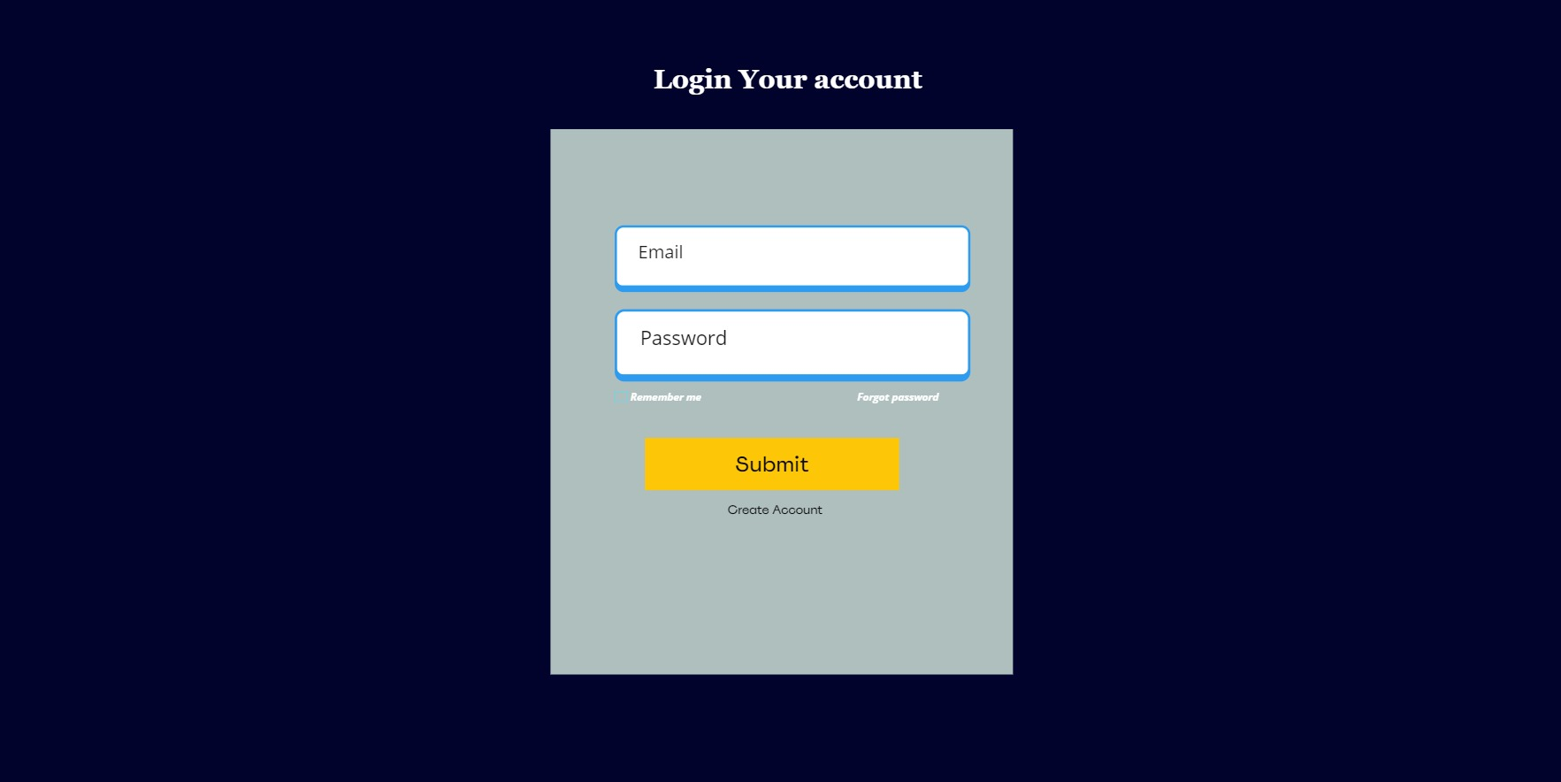

**Title:** User Registration Functionality:

**Description:** This functionality allows new users to create an account by providing necessary registration details such as username, password, and email address. Upon successful registration, the system should send a confirmation email to the provided email address.

**Assumptions:**

* Users must have a laptop or computer to access this website.
* And users should have proper internet access.

**Dependencies:**

* User login functionality.
* User dashboard module.

**Preconditions:**

* End users must provide a valid first name, last name, email address, mobile number to register.
* Create a strong password using alphabets numbers and symbols.
* The system will send a One-Time Password (OTP) to the user's email address or mobile number. The user must enter the correct OTP to complete the account creation process.

**Postconditions**:

* User successfully created an account.
* Now users can login into their account.
* Users logged in time and IP address are logged for security purposes.

**Accptance criteria:**

* Users must provide a valid name, email address, password, phone number, and OTP during the registration process.
* If the user provides valid credentials, the system will redirect them to the login page, where they can enter their email and password to log into their account**.**
* If the user provides invalid credentials during registration, the system will display an error message: 'Please use a valid name, phone number, email address, and password.'

**Priority:** High

***Process Flow Diagram:***

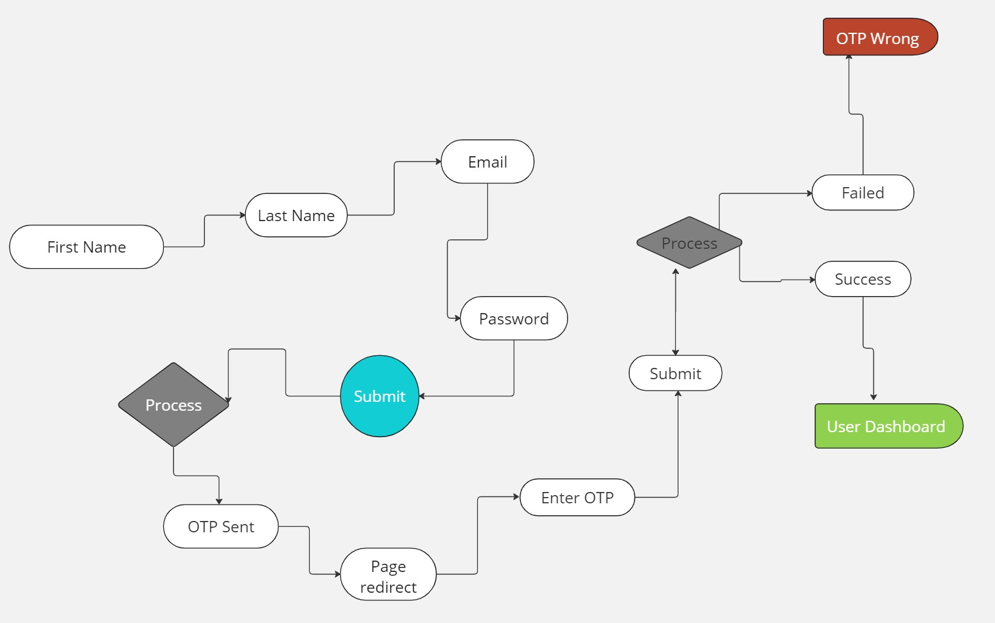

***Wireframe:***

**Title:** Navigation Bar

**Description:**

* ***Top left corner:*** 
  + Website Name: Display the name of the website.
  + Logo: accompany the website name with its logo.
* ***Top right corner****:* 
  + Modules:
    - Gyms
    - Classes
    - Training
    - About
* ***User access:*** 
  + If the user logged in, display the user dashboard module.
  + If the user is not logged in, display Signup/Login buttons instead.

**Assumptions:**

* The user must be on the website to access its features.
* A stable internet connection is required to use the website.

**Dependencies:**

* Yoga, cycling, strength.
* Competitions, access to personal training workout tips.
* Access to photo galleries, blogs and testimonials.
* User dashboard, sign up/login

**Preconditions:**

* The user must be on the website to access the navigation section**.**
* The modules should be highly interactive and user-friendly.
* End users should be able to click on the sign-up/login button.
* Users should be able to click on the dashboard button or icons if logged in.

**Postconditions:**

* If the user clicks on the gyms module it should redirect the user to a particular page.
* The user may click on the training module to see what options are available. And if the user clicks on the training module it should show Competition, personal training, and workout tips in the dropdown menu.
* If the user clicks on one of the options in the training dropdown menu it should be redirected to the respective page.
* If the user clicks on the About module it also should show photo galleries, blog, and testimonials in the dropdown menu.
* If the user clicks on one of the options under the about module it should also redirect the user to the respective page.
* if the user clicks on the user dashboard module it takes the user to the private dashboard.
* Finally, if the user clicks on the sign up/login button the page should redirect to the account creation page where user can create an account or can see the login option available.

**Acceptance criteria:**

* To access the navigation modules, the user must be on the website.
* To access the user dashboard, the user must be logged into their account.

**Priority:** Medium

***Wireframe:***



***Process Flow Diagram:***

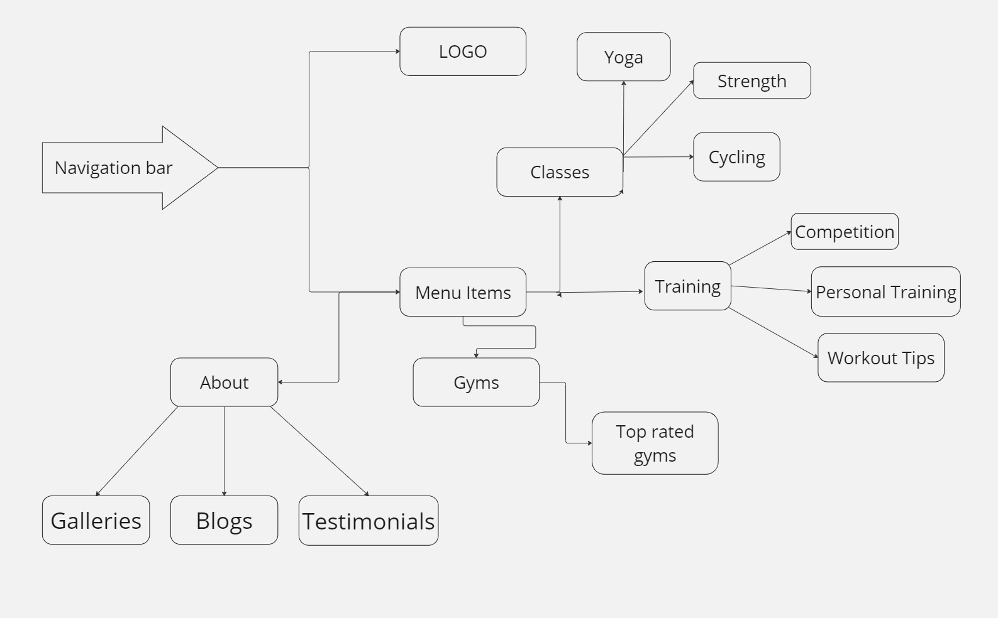

**Title:** Search by zip code

**Description:**

The system will enable end users to locate nearby gyms by simply entering their zip code into the designated zip code field.

**Assumptions:**

* A user must be on the website to use this feature.
* A stable network connection is required to search gyms just by entering zip codes.

**Dependencies:**

* Various gyms across the world.
* Courses and training are offered by various gyms.

**Preconditions:**

* An end user must be logged in before searching gym just by entering zip codes.
* Users must have a laptop or computer to access this website.
* To access this website a proper network connection is required.
* A user should enter only a valid zip code.

**Postconditions:**

* Users can see what the gyms are nearby that zip code.
* An end user can identify what are the various classes and training offered by various gyms and their ratings.

**Acceptance criteria:**

* Users must search for gyms with a valid zip code.
* If the end user provides invalid zip code, then the system will display an error to enter a valid zip code.

**Priority:** High

***Wireframe:***

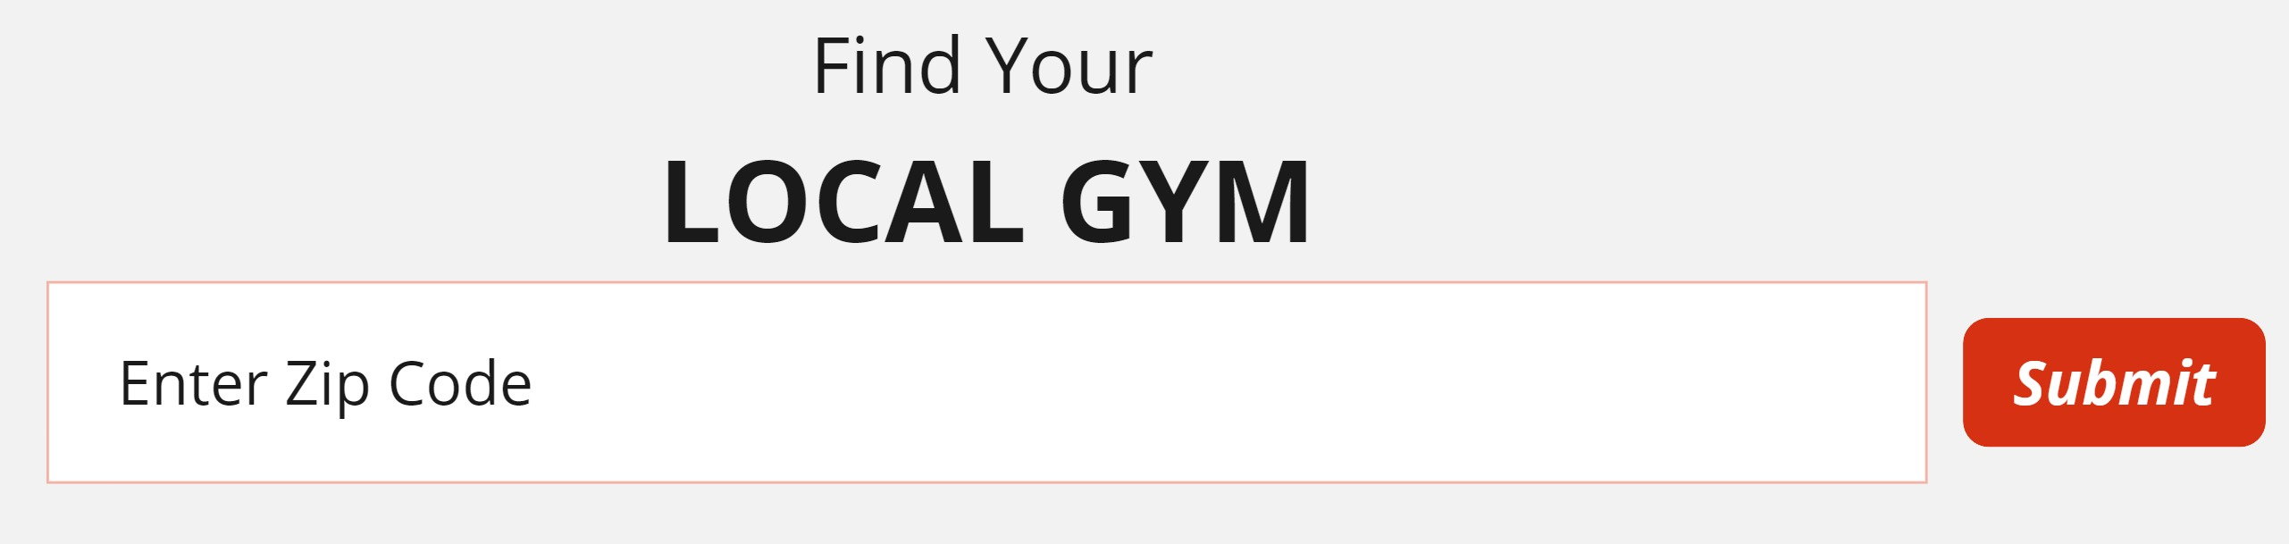

***Process Flow Diagram:***

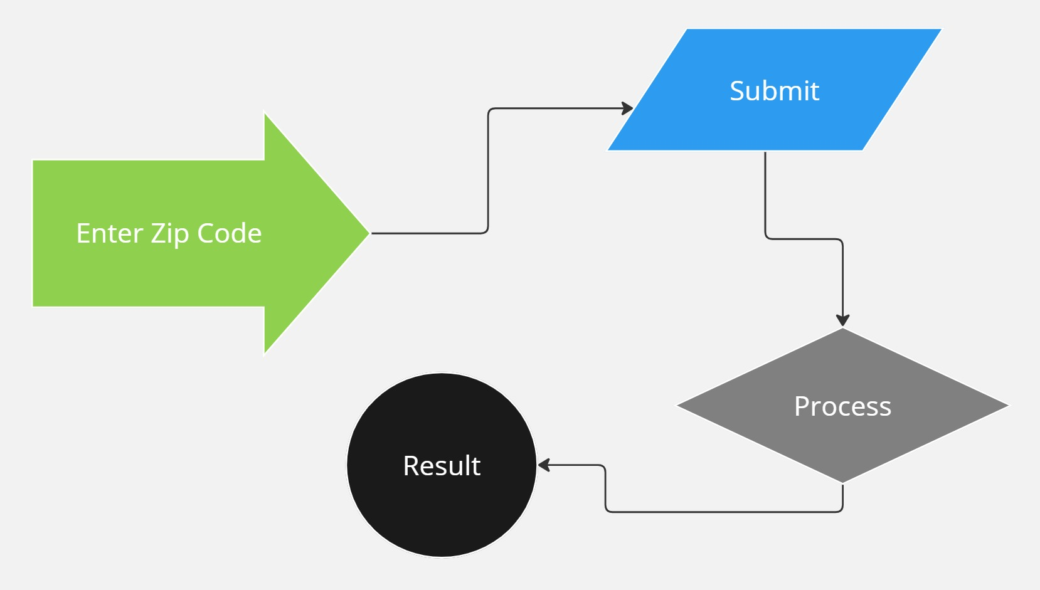

## 4.2s Non-Functional Requirements

**Performance:**

* The system must return gym search results within 3 seconds.

**Usability:**

* The zip code field must support both numerical and alphanumeric inputs.

**Security:**

* User data must be encrypted during transmission and at rest.

**Scalability:**

* The system must support up to 10000 concurrent users without performance degradation.

**Compliance:**

* The system must adhere to all applicable laws and regulations governing the protection of user data. This includes ensuring data privacy, securing personal information, and maintaining compliance with international and local data protection standards.

**Interoperability:**

* The system must integrate seamlessly with google maps for location services.

# 5. Assumptions and Constraints

**Assumptions:**

* **Resource Availability**: It is assumed that all required project resources (personnel, hardware, software) will be available as needed throughout the project duration.
* **Stakeholder Engagement**: It is assumed that key stakeholders will be available for meetings, reviews, and approvals at critical milestones.
* **Data Accuracy**: It is assumed that the data provided by stakeholders is accurate, complete, and up to date.

**Constraints:**

* **Budget**: The project must be completed within a budget of $10000.
* **Time**: The project must be completed and delivered within six months.
* **Technology**: The project must use the existing enterprise CRM system as the primary platform.
* **Compliance:** The system must adhere to all applicable laws and regulations governing the protection of user data. This includes ensuring data privacy, securing personal information, and maintaining compliance with international and local data protection standards.
* **Scope**: The project must deliver the functionalities outlined in the scope section without deviation.

# 6. Glossary

* **BRD:** A formal document that outlines the business needs and requirements of a project.
* **Stakeholder:** Any individual or group that is involved in the outcome of the project.
* **Assumption**: A statement taken to be true for planning purposes, though not yet verified.
* **Constraint:** A limitation or restriction that the project must operate within, such as time, budget, or resources.
* **User interface (UI):** The means by which a user interacts with a system, including screens, menus, and icons.
* **Performance:** The speed, responsiveness, and stability of a system under various conditions.

# 7. Approval

## 7.1 Sign-Off

